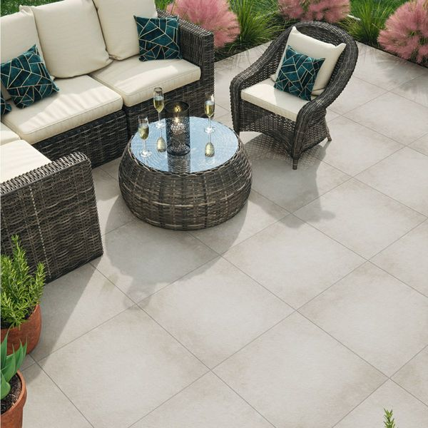**Leinz Grey Porcelain:**

## **Product Description**

Much more durable than traditional concrete slabs, our porcelain Leinz Grey Slab Tiles are hard-wearing, easy to clean, and have an R11 anti-slip surface! Create a gorgeous neutral toned patio space in your garden, where you can lap up the sun with your friends and family!

Have you tried our [20mm Paving Slab Trims](https://www.wallsandfloors.co.uk/20mm-paving-slab-trims)?

**What's special about these tiles?**

> Gorgeous grey colour

> 20mm thick durable porcelain

> Stone effect design for a natural look

> Easier to clean than concrete slabs

> R11 anti-slip surface

**Try before you buy**

If you'd like to take a closer look at these gorgeous slabs inspired by natural stone, order a sample! Sample tiles come full size and with free delivery, and they're a great way to see a tile's true size, colour and finish. You can also see how it looks in your chosen room.

**Have you seen our selection of Norcross Rock-Tite products? They're perfect for fixing and completing outdoor projects!**

## **Product Info**

* Product ID: 44494
* Tiles Per SQM: 2.8246592754749
* Sale by: Per SQM
* Size: 595x595x20mm
* Weight: 13.75 KG
* Material Type: Porcelain
* Finish: Matt
* Colour: Grey
* Suitability: Floors
* Area Of Usage: External
* Grade: 4
* Rectified Edge: Yes
* Underfloor Heating: Yes
* Anti Slip Grade: R11 / 35 Degrees
* Document: [20mm Installation Guide](https://m2.wallsandfloors.co.uk/media/amasty/amfile/attach/20mm-installation-guide_4.pdf),[Cleaning and Protection Guide](https://m2.wallsandfloors.co.uk/media/amasty/amfile/attach/ltp_-_walls_floors_-_external_porcelain_-_cleaning_and_protection_guide_-_april_2020.pdf)
* Thickness (mm): 20